Create a React Application “eventexamplesapp” to handle various events of the form elements in HTML.

CurrencyConvertor.js

import React, { Component} from 'react';

class CurrencyConvertor extends Component{

    constructor(props){

        super(props);

        this.state ={

            amount: '',

            currency: ''

        };

        this.handleSubmit = this.handleSubmit.bind(this);

        this.handleAmountChange = this.handleAmountChange.bind(this);

        this.handleCurrencyChange = this.handleCurrencyChange.bind(this);

    }

    handleAmountChange(e){

        this.setState({ amount: e.target.value});

    }

    handleCurrencyChange(e){

        this.setState({ currency: e.target.value});

    }

     handleSubmit(e){

        e.preventDefault();

    const conversion = 80;

    const converted= (this.state.amount)\*this.conversion;

    alert(`Converting to ${this.state.currency} Amount is ${converted}`);

    }

    render() {

        return (

                <form onSubmit={this.handleSubmit}>

                    <label>

                        Amount:

                        <input

                    type="number"

                    value={this.state.amount}

                    onChange={this.handleAmountChange}/>

                    </label>

                    <br />

                    <label>

                        Currency:

                        <textarea

                        value={this.state.currency}

                        onChange={this.handleCurrencyChange}

                        />

                    </label>

                    <br />

                    <button type="submit">Submit</button>

                </form>

        );

    }

}

export default CurrencyConvertor;

App.js

import React, {usestate} from 'react';

import CurrencyConvertor from './CurrencyConvertor/CurrencyConvertor';

class App extends React.Component{

  constructor(props){

    super(props);

    this.state={

      counter: 1

    };

    this.decrement=this.decrement.bind(this);

    this.sayWelcome=this.sayWelcome.bind(this);

  }

  increment =(e) =>{

    this.setState(prev => ({

      counter: prev.counter+1

    }));

    this.sayHello();

  };

  decrement(){

    this.setState(prev => ({

      counter: prev.counter-1

    }));

  }

  sayHello()

  {

    alert("Hello! Member!");

  }

  sayWelcome(){

    alert("Welcome");

  }

  handleSyntheticClick = () =>{

    alert("I was Clicked");

  };

  render(){

    return(

      <div style= {{ padding: '20px'}}>

        <p>{this.state.counter}</p>

        <button onClick={this.increment}>Increment</button>

        <br />

        <button onClick={this.decrement}>Decrement</button>

         <br />

         <button onClick={this.sayWelcome}>Say Welcome</button>

          <br />

          <button onClick={this.handleSyntheticClick}>Click on me</button>

          <h1 style={{color:'green'}}>Currency Convertor!!!</h1>

          <CurrencyConvertor />

          </div>

    );

  }

}

export default App;

Execution of code:

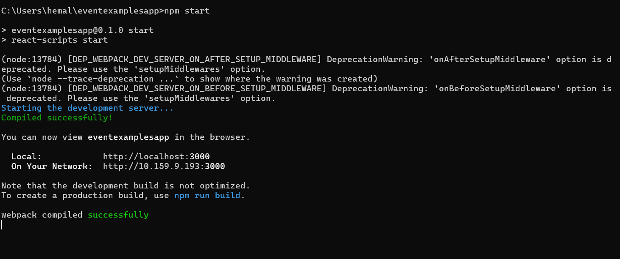

1. Create “Increment” button to increase the value of the counter and “Decrement” button to decrease the value of the counter. The “Increase” button should invoke multiple methods.
   1. To increment the value
   2. Say Hello followed by a static message.

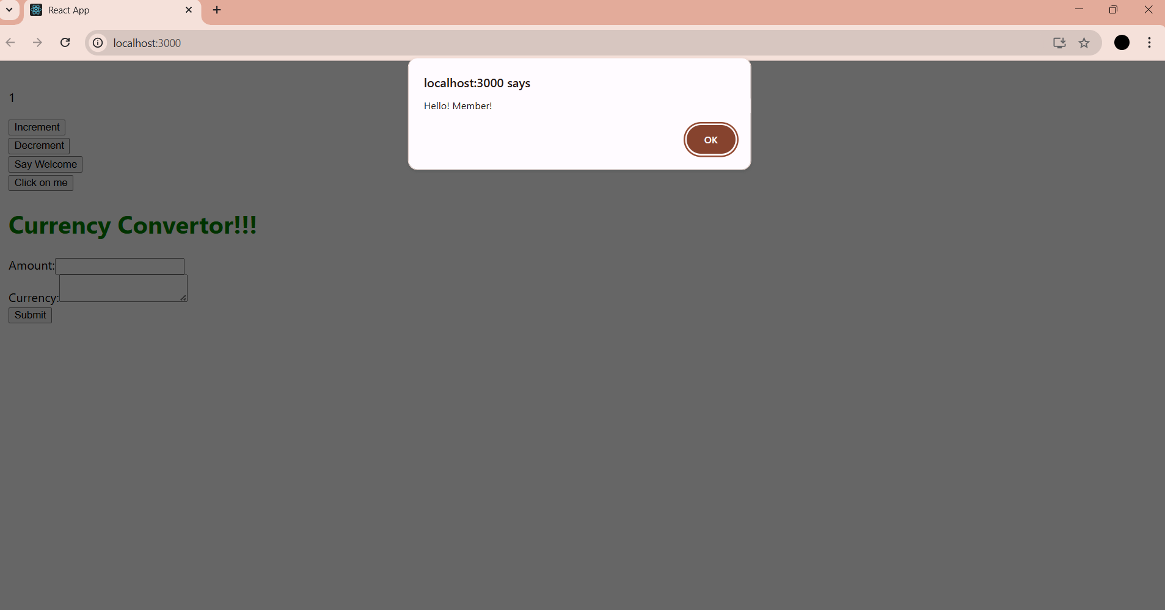

2.Create a button “Say Welcome” which invokes the function which takes “welcome” as an argument.

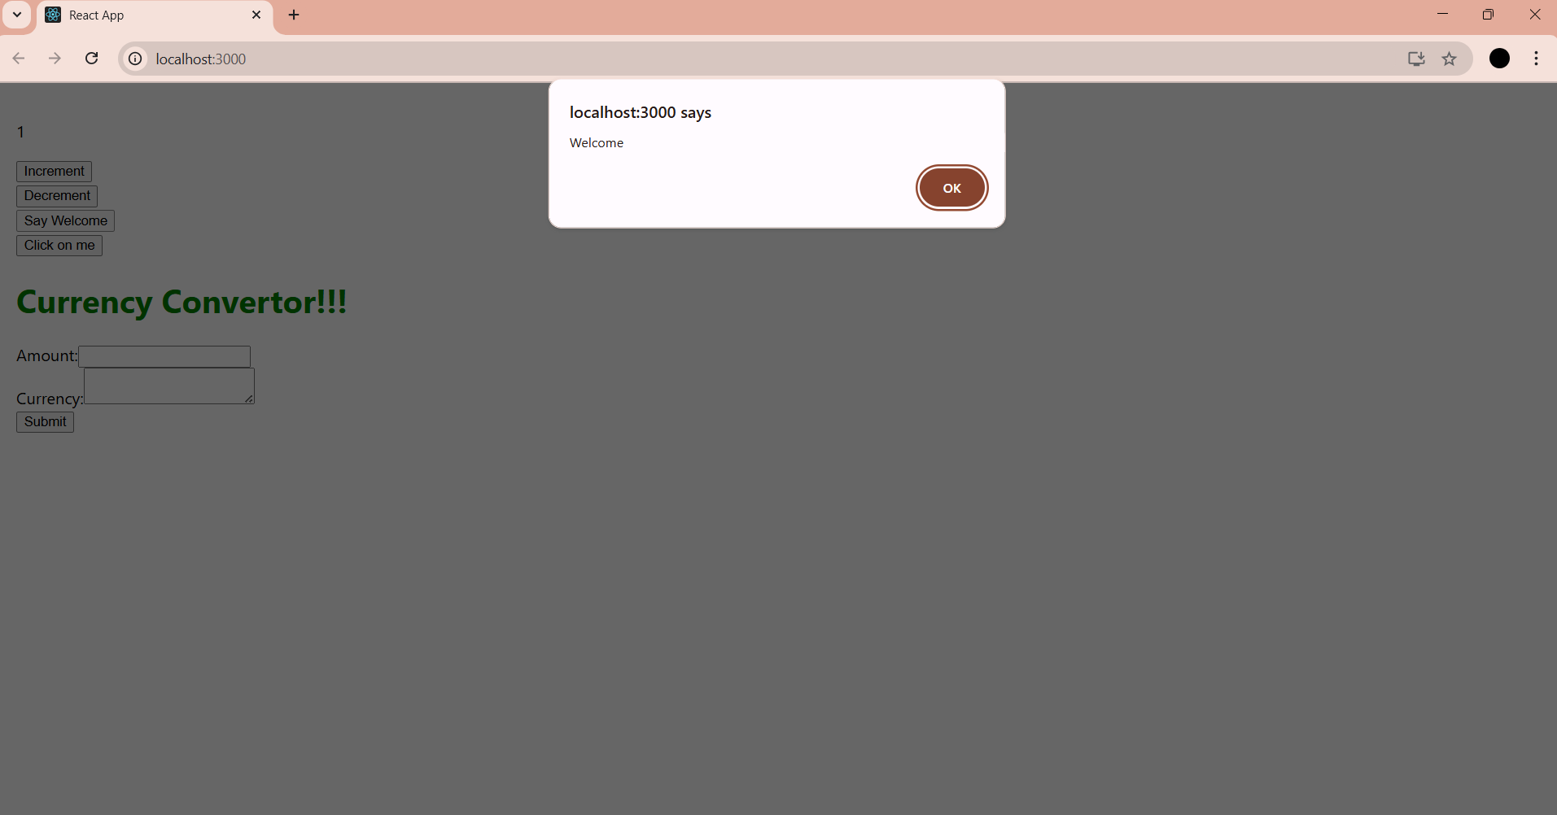

3.Create a button which invokes synthetic event “OnPress” which display “I was clicked”

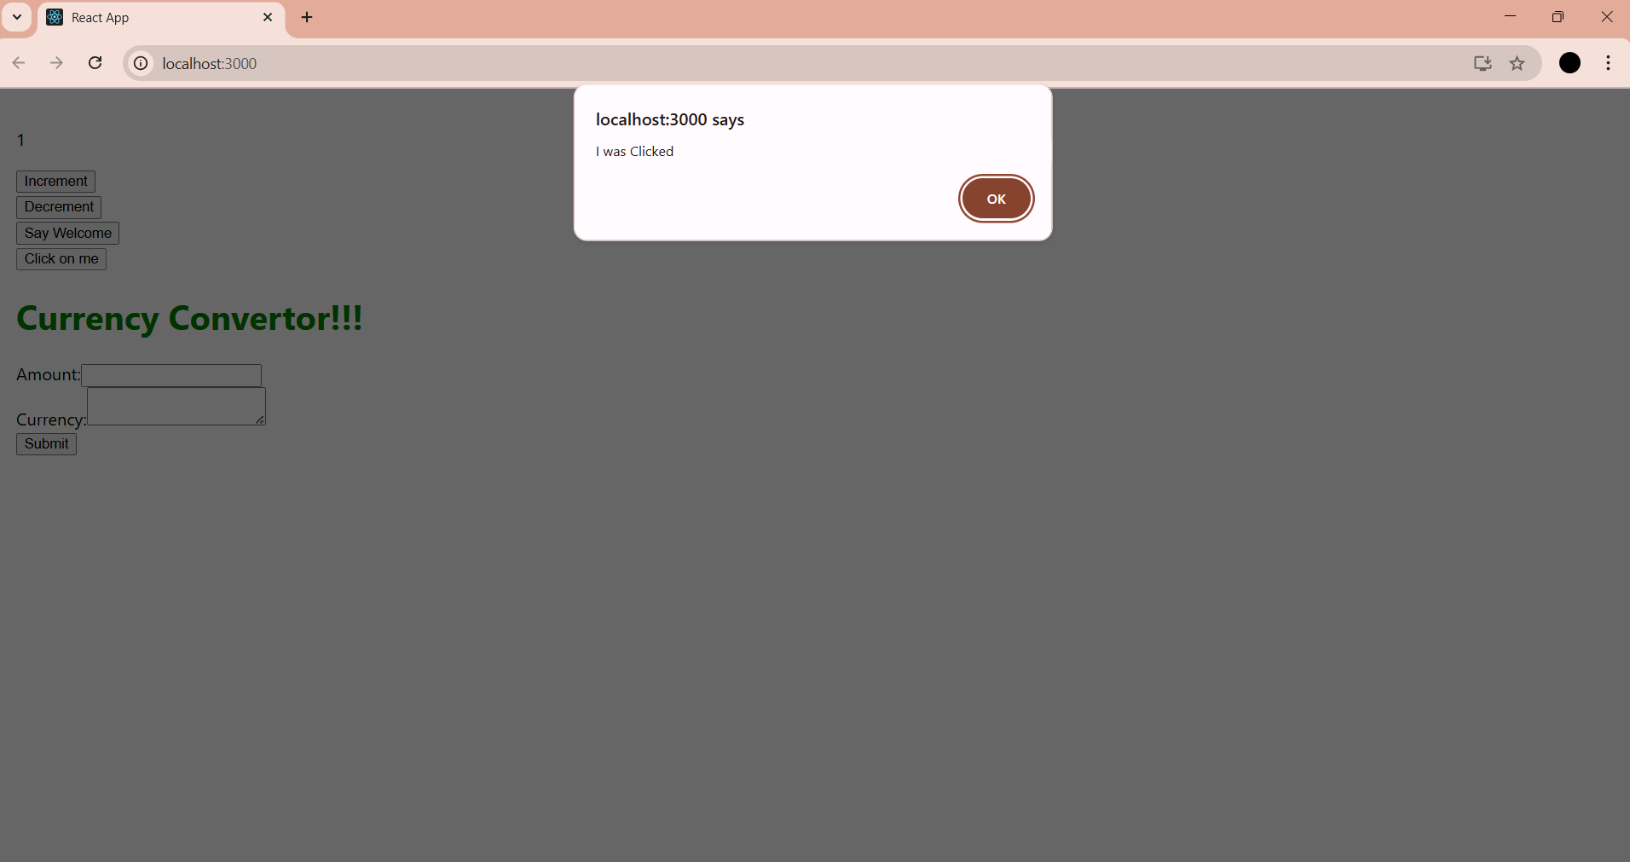

Create a “CurrencyConvertor” component which will convert the Indian Rupees to Euro when the Convert button is clicked.

